Books for designers
COVER | TITLE | AUTHOR | COMMENTS
 | Pattern Design for Torchon Lace | Jane Atkinson | isbn:9780713452426  English  Book  CD direct from Author
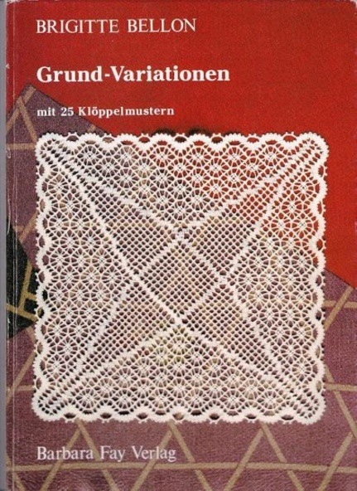 | Grund-Variationen | Brigitte Bellon | isbn:9783925184871  German
 | Building Torchon Lace Patterns | Bridget M. Cook | isbn:9780713486261  English  book
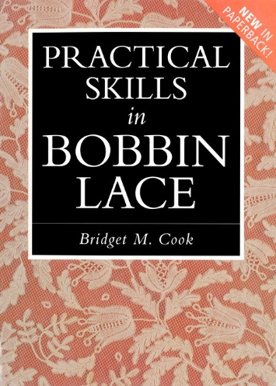 | Practical Skills in Bobbin Lace | Bridget M. Cook | isbn:0713459263  English  book  ebook
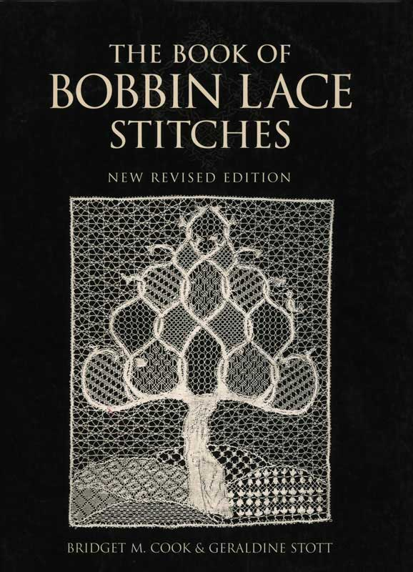 | The Book of Bobbin Lace Stitches | Bridget M. Cook & Geraldine Stott | isbn:0713487232 ISBN-13:978-0713487237  English, Spanish  Book  Ebook  At least 4 different covers
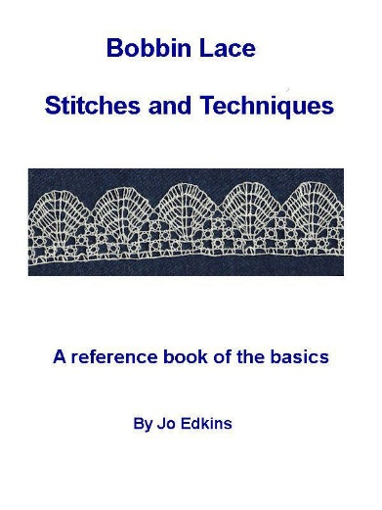 | Bobbin Lace Stitches and Techniques - a reference book of the basics | Jo Edkins | amazon:B008ZFCS7K  ebook
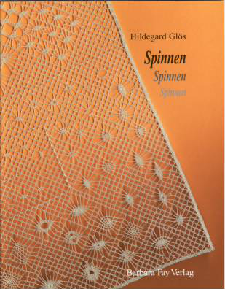 | Spinnen Spinnen Spinnen (Spider, Spider, Spider) | Hildegard Glos | isbn:9783925184222  German  book
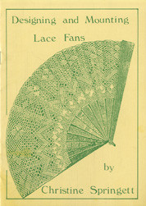 | Designing and Mounting Lace Fans | Christine Springett | Book  English
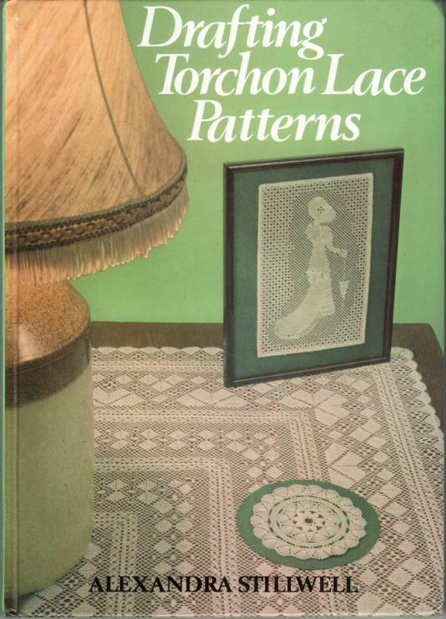 | Drafting Torchon Lace Patterns | Alexandra Stillwell | isbn:9780852196274  English  book
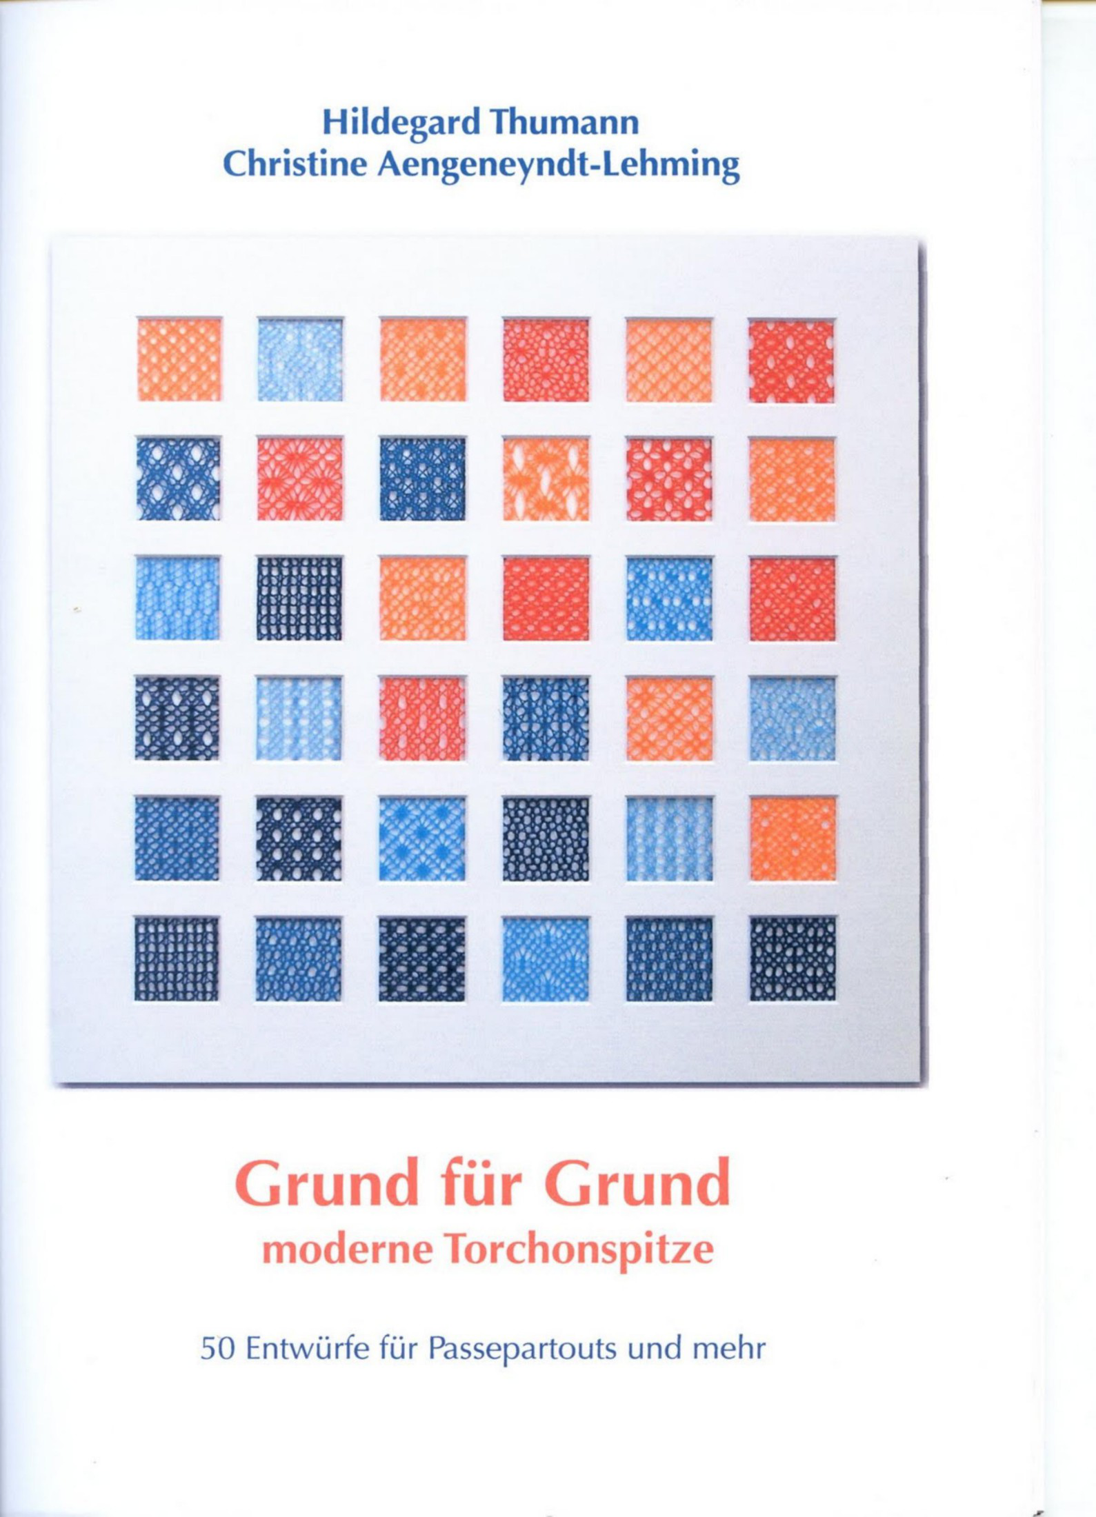 | Grunde fur Grund | Hildegard Thumann | German
 | Torchon Discover | Ulrike Voelcker | Loose sheets  English and German
 | Torchon Explore | Ulrike Voelcker | Loose sheets  English and German
 | Torchon Master | Ulrike Voelcker | Loose sheets  English and German
 | Color in Torchon | Jean Leader | DVD  in English

